*Department of Information Systems*

***Systems Design & Development***

**

**Systems Specification for Poppel**

*POPPEL*

*]*

***Team Members***

|  |  |
| --- | --- |
| ***Student Number:***  ***MSVTAK002*** | ***Student Name:***  ***TAKUDZWA MASEVA*** |
| ***Student Number:***  ***DZNTAK002*** | ***Student Name :***  ***TAKUNDA DZINGIRAI*** |

**Plagiarism Declaration**

Full Name: ____TAKUDZWA MASEVA__________________________ Signed:____TM___________ Date: _10___/__18__/2022

Full Name: ________TAKUNDA DZINGIRAI______________________ Signed:________TD_______ Date: _10___/_18___/2022

**Table Of Contents**

1. Introduction 2

1.1. Overview of Specification 2

1.2. Context & Scope of System Specification 2

1.3. Design Assumptions & Constraints 3

2. User Interface & Dialogue Design 4

2.1. Wireframe Diagram or Windows Navigation Document 7

2.2. Screen Standards 8

2.3. Detailed Screen Layout 9

3. Design Sequence Diagrams 11

3.1. Design Sequence Diagram 1 11

3.2. Design Sequence Diagram 11

4. Design Class Diagrams 12

5. Entity Relationship Diagram 14

6. Report Design 14

6.1. Report 1 14

6.1.1. Detailed Output Requirements 15

6.1.2. Report Layout 15

7. Input-Output Standards & Controls 16

7.1. Formalised Outputs: 16

7.2. Built-In Validation to Ensure Requirements are Met 16

7.3. Input Integrity Controls 16

7.4. Output Integrity Controls 16

8. Implementation Plan 16

9. Test Plan 17

9.1. Test Environment 17

9.2. Test Items 17

9.3. Test Approaches 17

9.4. Problem Tracking (Test Cases) 18

9.5. Test Schedule 18

# Introduction

## Overview of Specification

This document provides an overview of the Poppel Ordering system. It provides information regarding what the system should do, what the system should do, how it will interact with the end users, how it will interact with its environment as well as the end users of the system and finally the hardware and software requirements of the system. To begin with, this document will first give a quick description of the project and then provide some context and background solution. After that it will move on to unpack the assumptions made during design before finally unpacking the constraints in the system design. After all that, the document will then look into how the interfaces of the system will look like using wireframe diagram before moving on to look at the system’s database structure and the reports that the system will be able to generate as well as the layout of these reports. The document will then move on to the input-output standards and controls where how the system ensures that data is seen by the rightful person and that the system stores only the correct data format. After that the implementation plan of this project will be looked into and finally the test plan.

This project began with getting to understand Poppel’s current ordering system and how it worked and the problems it came along with were also identified then there was a proposed system with alternative solutions on which a risk assessment, feasibility assessment were all carried out and recommendations to management were made and all this was part of the Business Case document that was given to management. After that a user specification document was also drafted with information about what the system needs to do and the scope of the system. After all that came the design phase where information about how the system will do what it needs to do was communicated in the form of models and now the project is in the implementation phase where the software is being programmed and there will be unit testing and integration of the components before it is deployed.

## Context & Scope of System Specification

Poppel has been growing rapidly and have been using an inefficient manual based system to process orders. From registering customers to employees at Poppel working in transferring data from one paper to another and spreadsheets, the ordering process is cumbersome and time consuming and prone to a lot of human errors . This then led to Poppel deciding to move to another system and many solutions were proposed and it was decided to introduce an automated/online based system to solve some of the problems Poppel experienced. With the system, Poppel aims to remove all the paperwork that was involved in ordering and registering a customer. With the system, Poppel aims to reduce the numbers of stock losses and have a stock management system that updates the quantities after a purchase so that they keep stock counts.

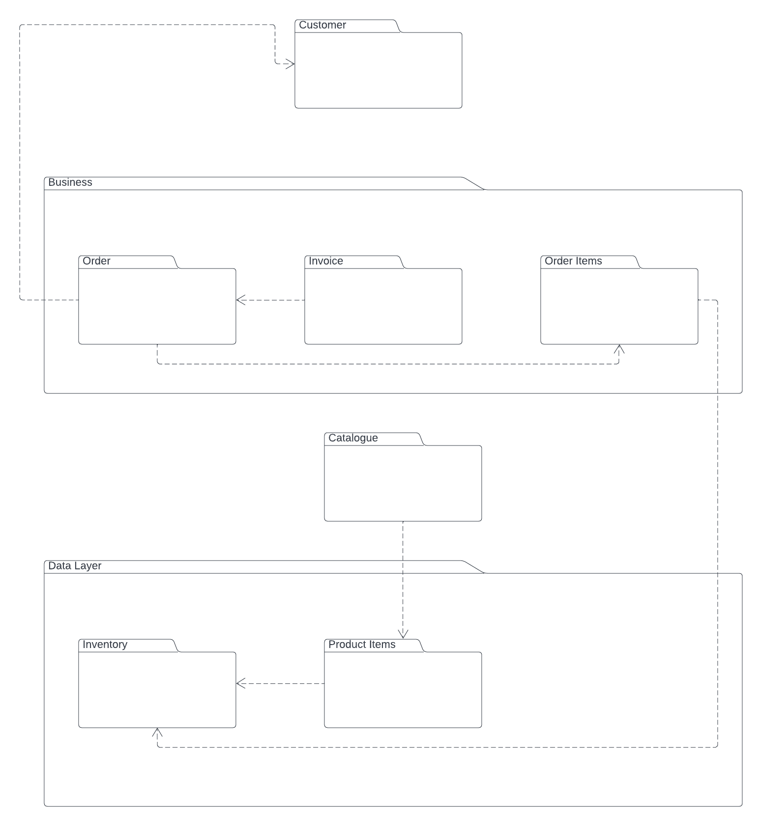

## Design Assumptions & Constraints

Some of the design constraints included the amount of space that the current computers Poppel has and so designs were constrained to a system that Poppel would also manage to install on their existing computers. The other design constraint was that the system needed to look closer to what the employees were already used to doing and not deviate too much from that.

During design, it was assumed that a customer would not at any point in time get expired products, before selling this is not even being checked.

# User Interface & Dialogue Design

*It is a good habit to always write a very short introduction to each new section (i.e. never have heading directly after each other without some explanation. Provide the layout of all input data screens or graphical user interfaces (GUIs) (for example, windows). Provide a graphic representation of each interface. Define all data elements associated with each screen or GUI, or reference the data dictionary. This section should contain edit criteria for the data elements, including specific values, range of values, mandatory/optional, alphanumeric values, and length. Also address data entry controls to prevent edit bypassing. Discuss the miscellaneous messages associated with operator inputs, including the following:*

* *Copies of form(s) if the input data are keyed or scanned for data entry from printed forms*
* *Description of any access restrictions or security considerations*
* *Each transaction name, code, and definition, if the system is a transaction-based processing system*

*The log in form*

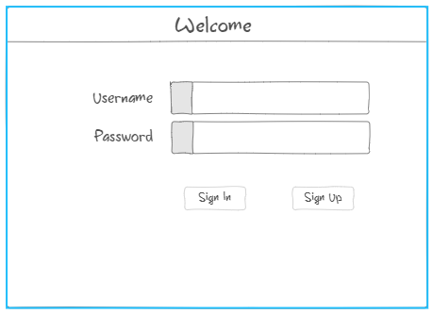

This is the first input data form. It has two textboxes that take in a user’s username and password and are clearly labelled to let the user know what each of them will take. Both textboxes will take in any type of data but the password text field is constrained to take a minimum password of 4 characters and anything less than that the user will be notified by the system that their password needs to have 4 or more characters when they click the sign up button. Both the username and password fields are also mandatory and when a user tries to sign up or sign in without filling them the system will also inform them that all text fields need to be filled. Anyone with access to the system can sign up and only sign in after that.

Customer Registration form

This is the other input data field that will be used to register a customer. The form can be accessed by anyone to update customer details, register a customer or delete a customer and there are no restrictions as to who can access it. To delete a customer, the customer Id has to be supplied to the ID field and to edit/update a customer details, the clerk has to just edit the details on the form and click on the update button. The form has textboxes that have to be filled with data and there are labels next to each text field to avoid errors from the clerk and let the clerk know what need to be inputted in each text box. All the text fields on the form are mandatory and an attempt to register a customer without filling all of them will result in the system notifying the Clerk that all the text fields need to be filled. The text fields take any data but the credit status text field is constrained to OK or NO values only anything other than that the system will notify the Clerk that incorrect data entered and tell them the type of values that are needed. The blacklist status text field is also constrained to take in a value of either true or false and anything other than that, the customer will not be registered and the Clerk will be notified of what they are doing wrong. There is also a data grid view next to the textboxes that will be displaying all the customers and a clerk can click a customer on the grid view which results in the text boxes being populated with that customer’s data.

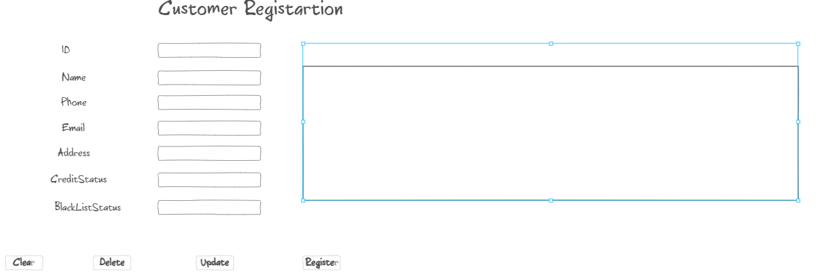

Product Updates, Deletes and Add Form

The Product form is used to perform all CRUD operations. For security purposes, only an admin can perform the delete, update and delete operations and a Clerk can only view the products. On the Home page, when a Clerk clicks the view products button, then the system asks the user if they want to edit the products. If the user clicks yes, then since it’s only an admin who can perform those operations on Products, an Admin Log In page pops up and the user, in this case anyone with the role of admin. The Admin log in form is just the same as the first log in form but no one can sign up using that form.

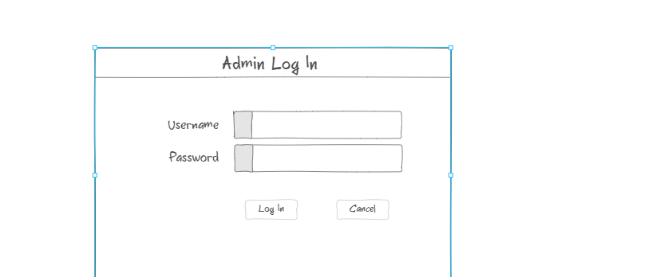

Once granted access, textboxes and labels for updating the products are then enabled and can be used.

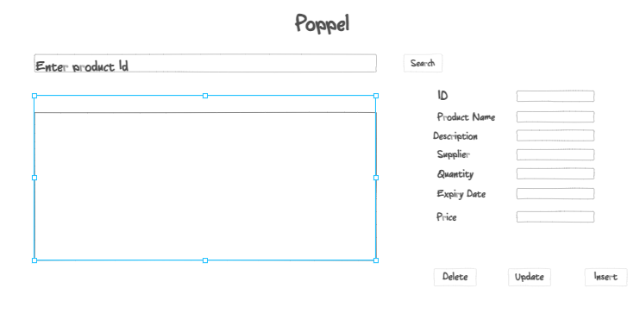

All the products will be displayed on the grid View next to the text boxes and the admin can search a product by Id and then go on to delete that product by clicking the Delete button and after clicking it for confirmation, the user is prompted with a message asking if they are sure they want to delete the product, if yes, then its deleted otherwise it’s not deleted. The admin can also search the product by Id and then go on to modify it before clicking on the Update button to permanently change the product, however if the admin tries to update a product using a product id and the product is not there, then the system tells them that product does not exist. To insert a product, all textboxes must be filled with the product’s information and if the admin tries to insert a product with missing information, the system notifies them that all textboxes must be filled. The expiry date textbox has a placeholder value to show the user the format of the date that has to be entered and the quantity text field is constrained to only take in integer values.

Customer Order Form

This is the form that will be used to capture a customer’s order. It can be accessed by anyone handling a customer’s order. It has two data grid views, the left one showing all the products from which the clerk can click on a product and then the product’s details are populated on the text boxes below but then they are disabled so the clerk cannot edit anything that is populated on those textboxes. The clerk can then only specify the quantities of that product that a customer needs in the textbox labelled quantity and only takes in a value of type integer and anything other than that results in the system notifying the clerk where the mistake is when the clerk clicks the add button. The add button then adds the product to the Customer order and displayed on the data grid view on the right. The customer’s order can be manipulated to delete it, update it by using the buttons with the text delete and update respectively. After everything the clerk confirms the order by clicking the confirm order button

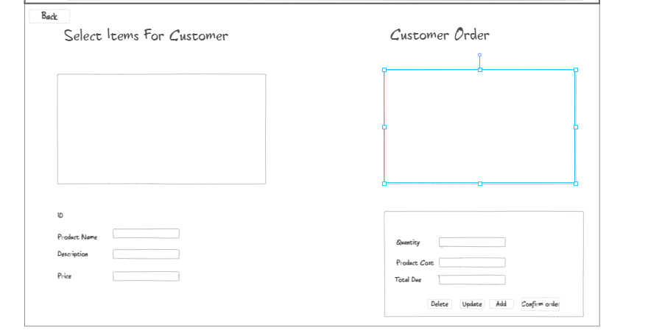

## Wireframe Diagram or Windows Navigation Document

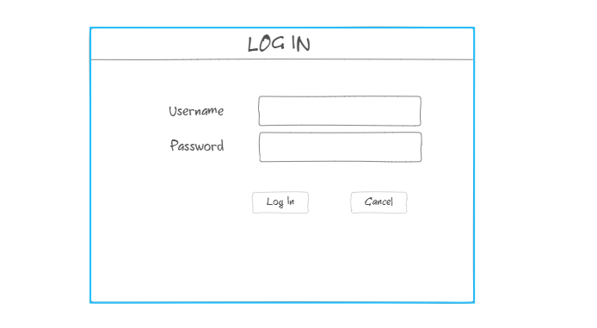

The home page

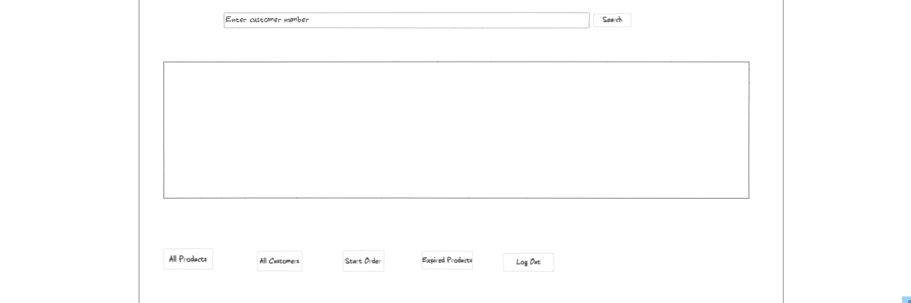

## Screen Standards

* *Once you have identified the various forms and their purpose, define your overall screen standards (layout, colour and overall appearance).*

*The log in page is just a simple form with the usual textboxes that people are used to. This is the form that the user, either a clerk or admin will use to gain access into the system. It is simply white and has a sign up and sign in button. The sign in button works after all the text fields have been filled. The sign up button is used to sign up so that after that you can use the details to can access into the system.*

The customer registration form is used to capture customer details if that customer is not registered. It has textboxes with labels next to them that indicate what is supposed to be put into the textbox. After all the customer information has been captured, there is a register button that also has to be clicked to submit the details to the database where they will be stored. The customer form also has a 3 other main buttons, the clear button, which clears data that’s populating the textboxes on the form. The delete button deletes a customer with a specified id from the database records and the update button is used to update customer details in the database, the id for the customer whose details need to be updated has to be supplied. There is also a data grid view on the right of the textboxes that will be displaying all the customers in the database and a customer can be clicked from that grid view after which the customer’s details will then populate the textboxes with the correct details and then other operations like delete and update can be performed. There is also a back button that takes the user to the home page.

The Customer order form is used to capture a customer’s order. The form has 2 data grid views. The first grid view on the left, displays all the products in the database as well as all the information regarding a product. A Clerk will be able to select a product that a customer wants to order from that grid view which automatically populates the textboxes below the grid view with that product’s information but the textboxes are disabled for the clerk.After selecting the product a customer wants, the clerk then has to enter the quantity that the customer wants of that product and then press the Add button to add the product to the customer’s order. Once a product and its quantities have been selected and the add button is selected, that product’s quantities are then subtracted from the database thus reserving an item for that customer. The customer’s order as the Clerk is capturing it is displayed on the other data grid view on the right and a clerk can click on an item that has been added there and then update its quantities and then click the update button which then also adds then also updates the database quantities. A clerk can also delete a product that has been added already by clicking it on the data grid view with the customer order and then clicking on the delete button. After capturing an order, the clerk can then click the confirm order button and go on to generate an invoice and a picking list after that.

The product’s form can be viewed by the clerk and when being viewed by the clerk the textboxes are to edit the products are disabled, only an admin can do update, delete and insert operations. When it’s the admin, then the textboxes are enabled. The form is used to insert new products that are in stock into the database including information about that product and the quantities in stock. It is also used to update information about a product that is already in the database as well as tom delete a product. The form has a search bar that a clerk or admin can use to search a product with, if the product is found, it is displayed on the data grid view and if not found the system displays a message that the product is not in stock. The data grid view displays all the products that are in the database. To add a product, there are textboxes with labels of what needs to be entered and they all have to be filled before clicking on the insert button. The form can also be used to delete a product by entering its Id and clicking the delete button.

## Detailed Screen Layout

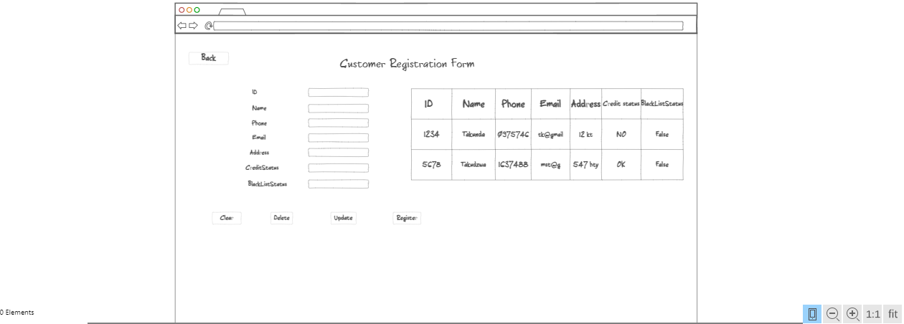

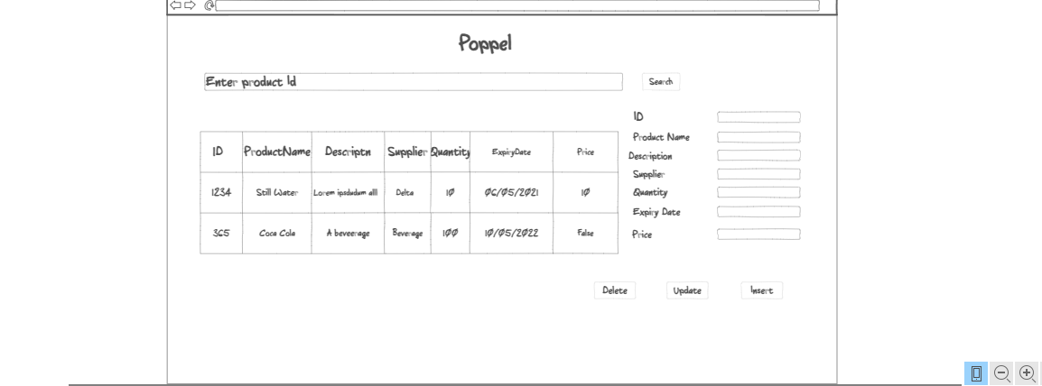

**

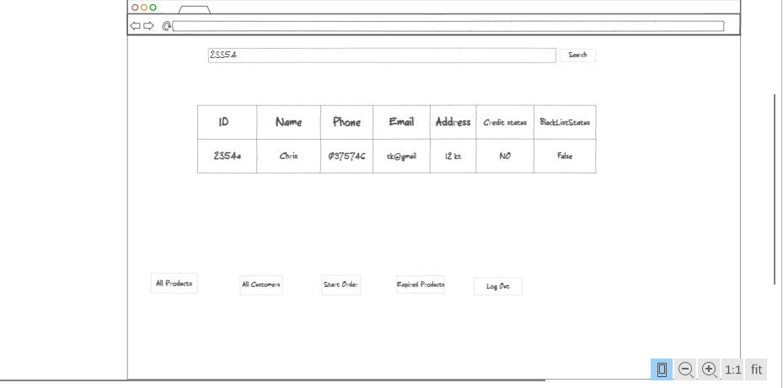

# Design Sequence Diagrams

## Design Sequence Diagram 1

## Design Sequence Diagram

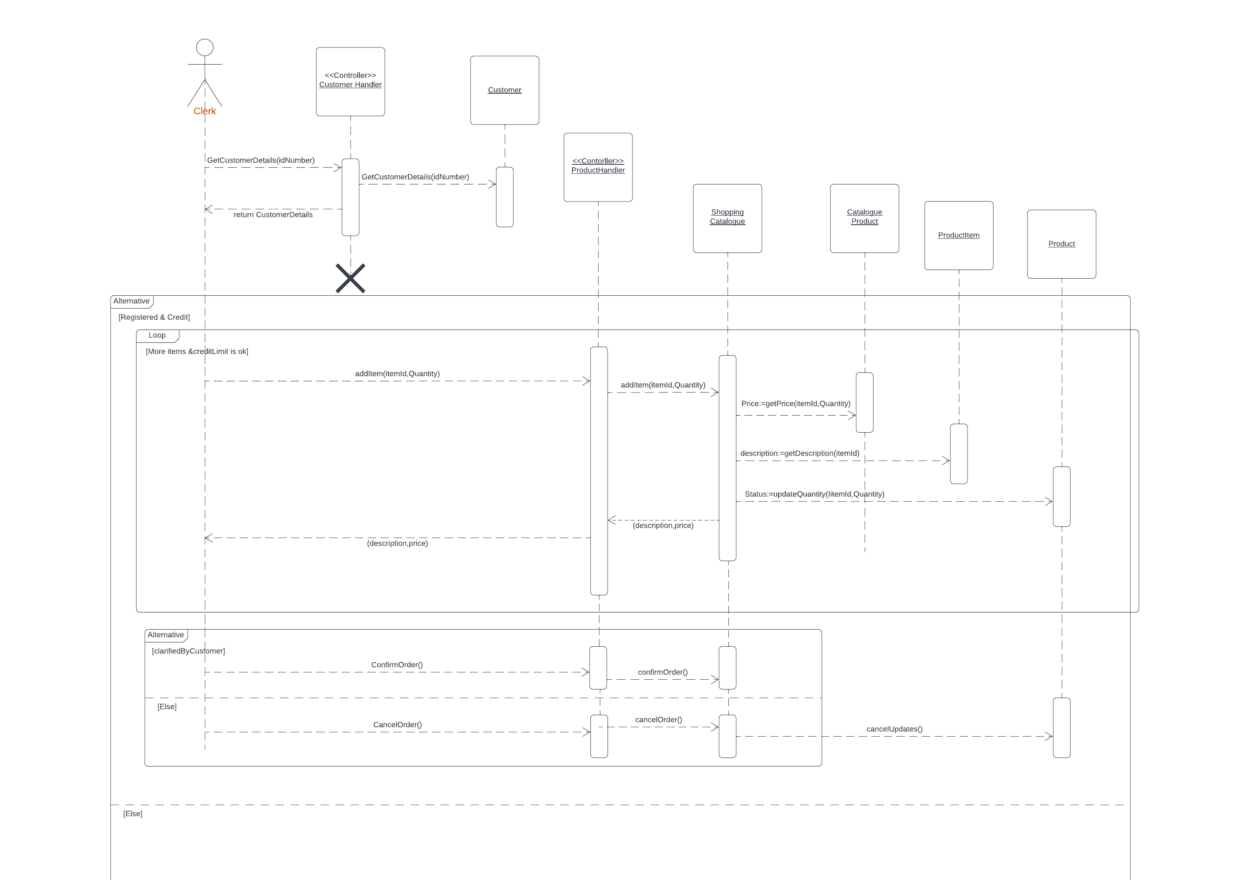

# **Design Class Diagrams**

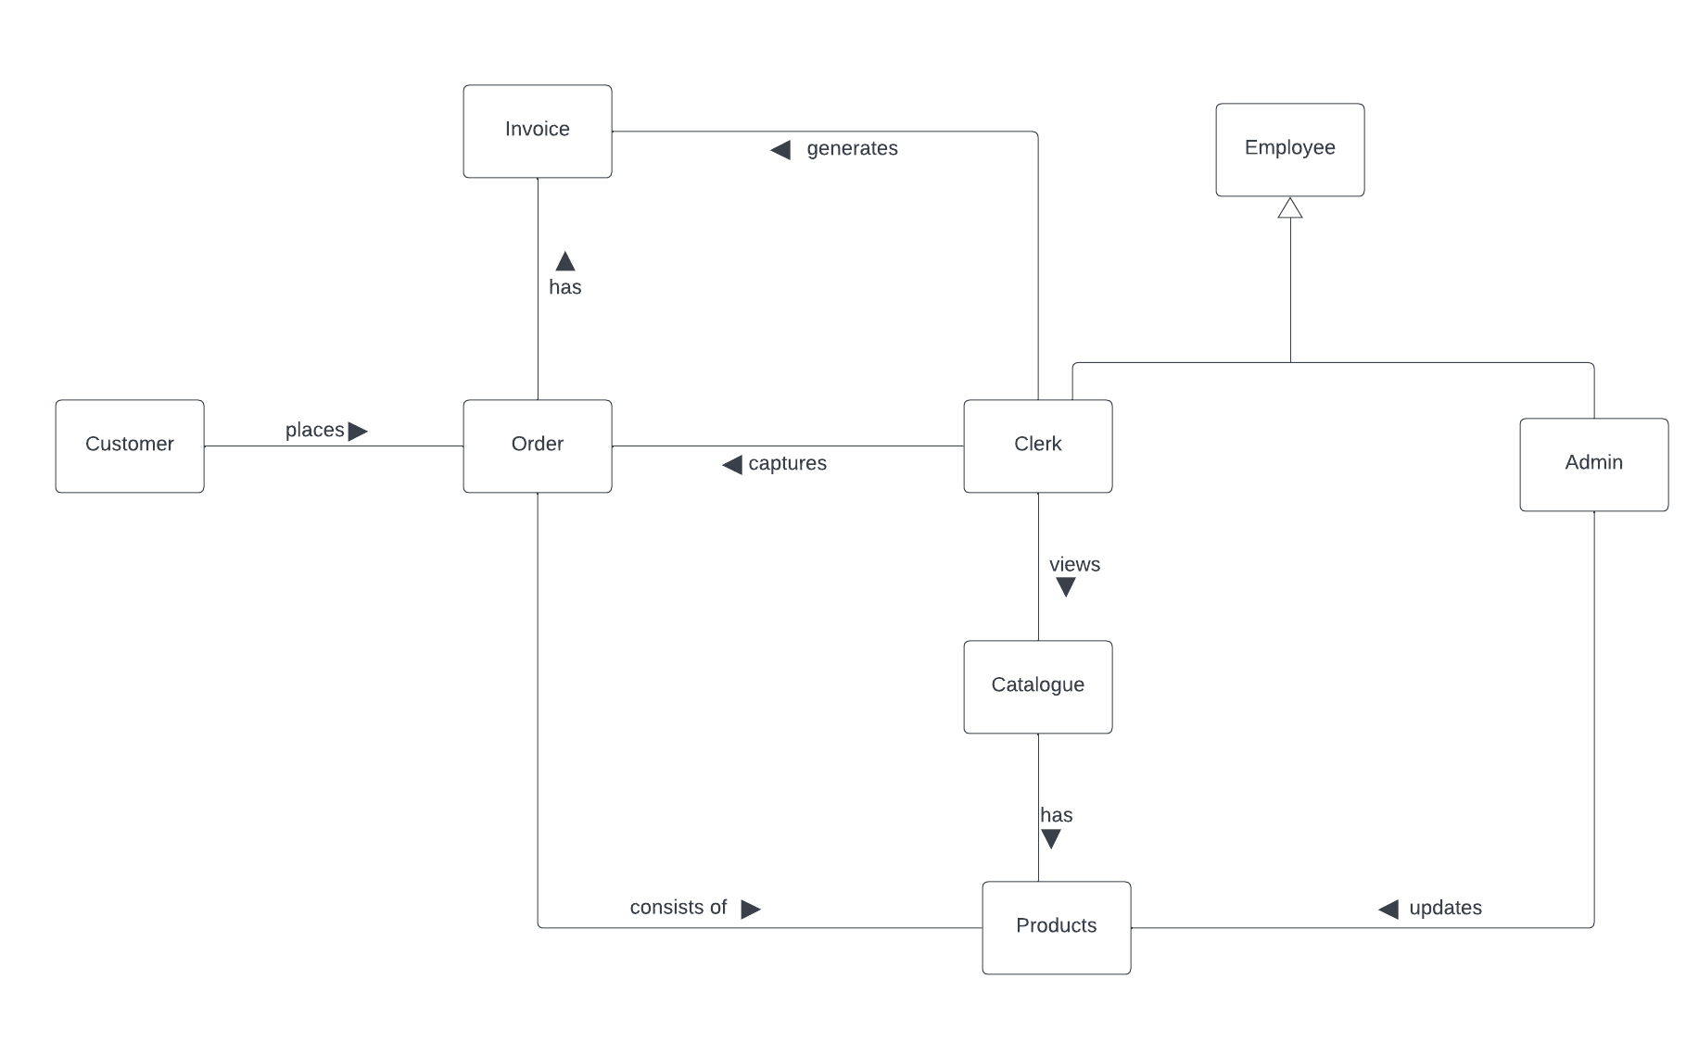

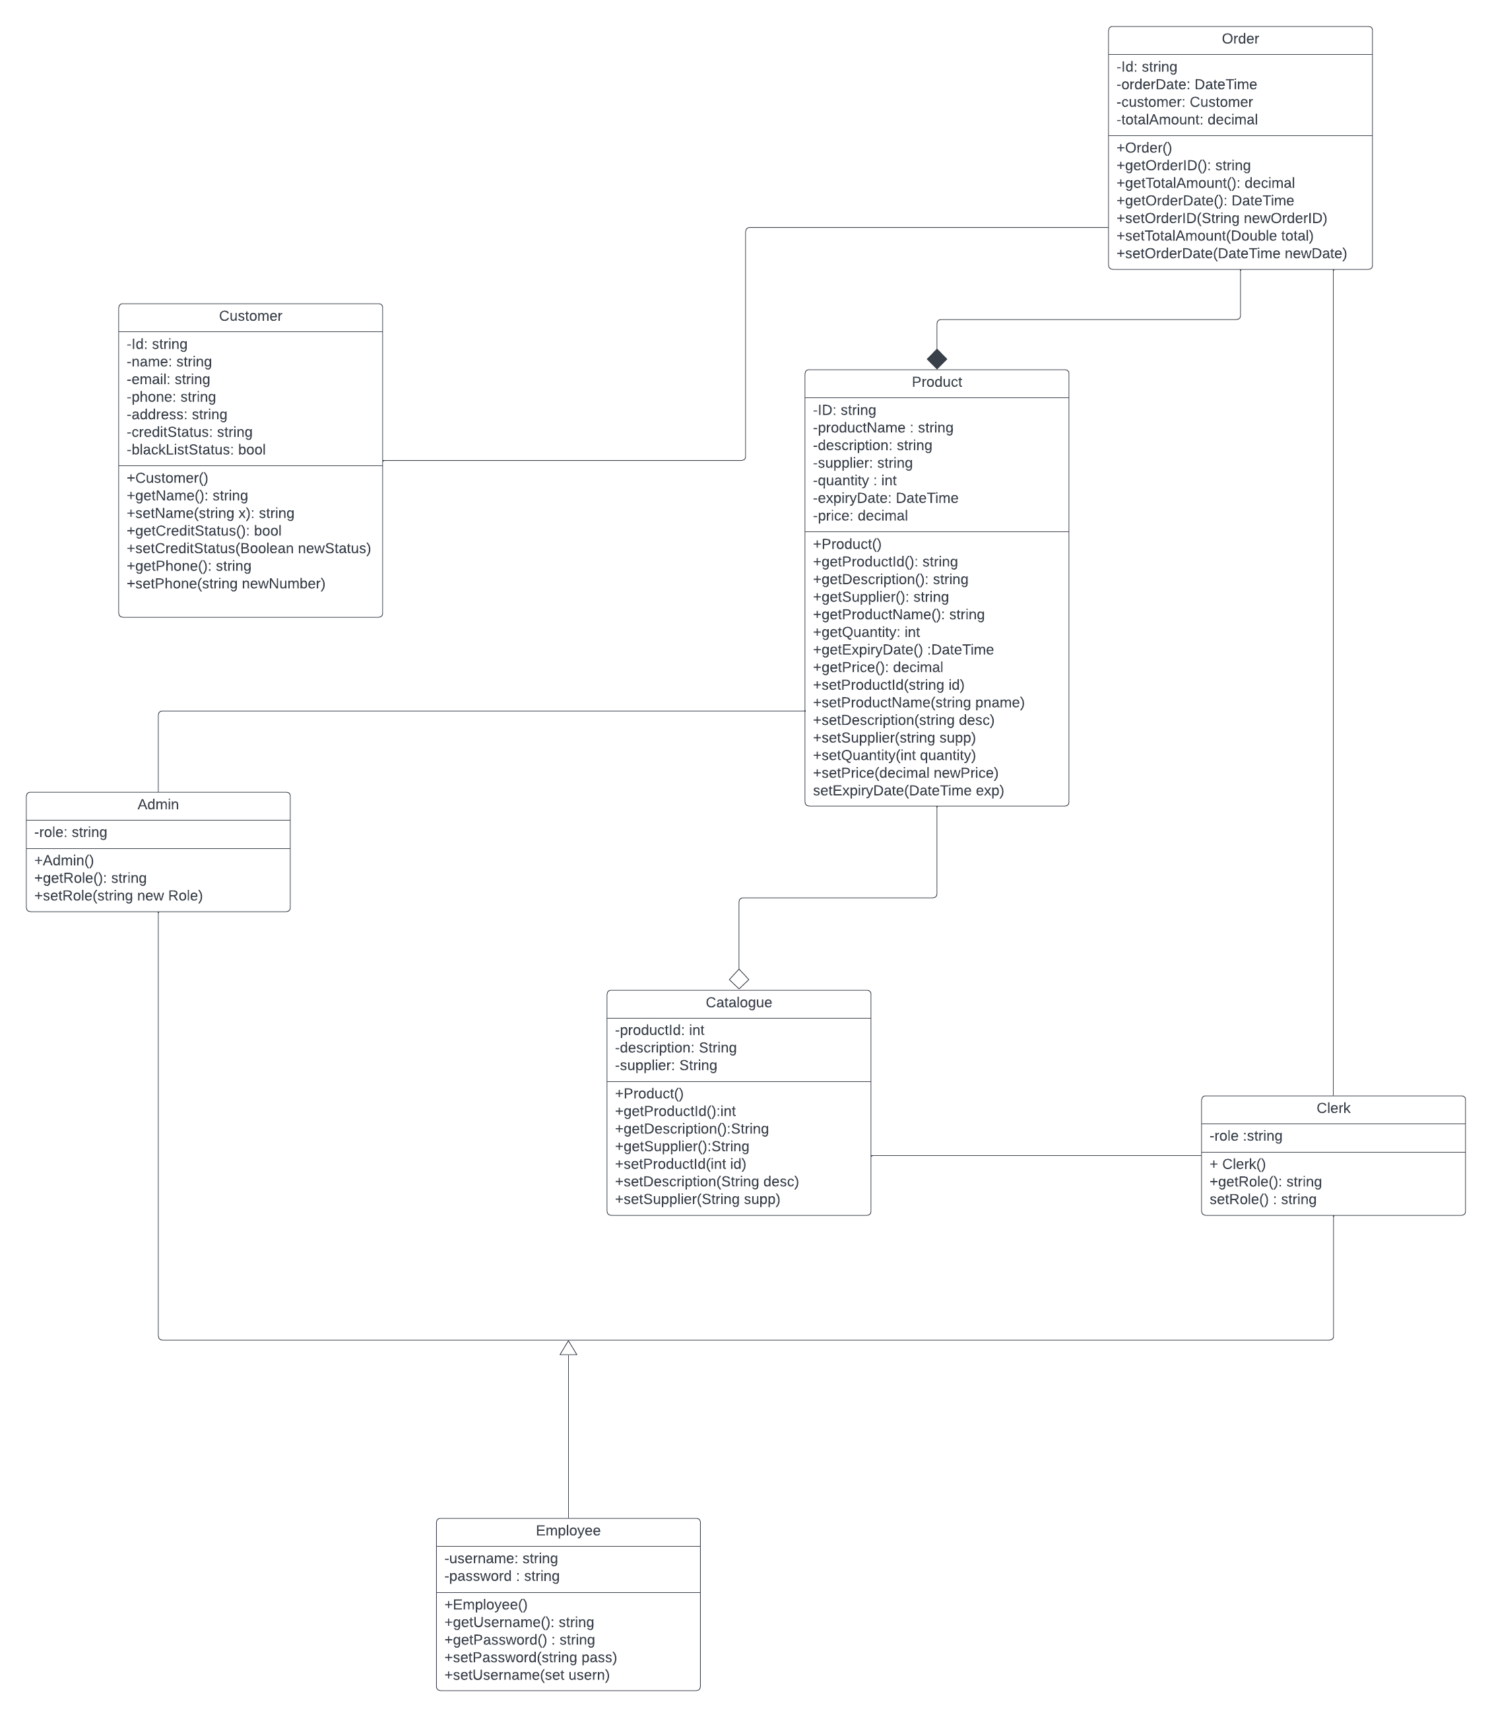

# **Entity Relationship Diagram**

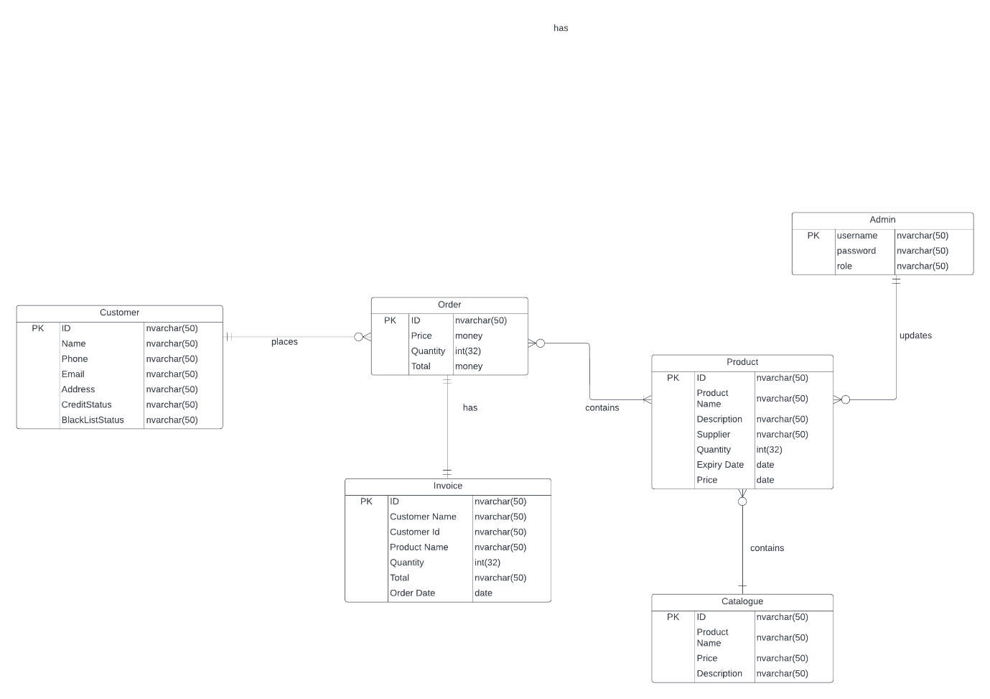

# **Report Design**

## Report 1

The Poppel Order processing System will be able to generate a report for all expired products. This will be done by clicking on the Generate Expired Products button that will be on the Home page. When clicked, the system generates a list of all the expired products from the database and displays them on the screen. This report will be valuable to the business as it can help the business to filter all the expired products and therefore update their quantities after excluding the products. The report will also be valuable to the business as it might. This report can also go a long way and save the business money that they might pay if something was to happen to a consumer as a direct result of eating those expired products and then the business is sued after consuming expired products and decides to sue the business. This report might be generated when the business wants to get rid of all the products that have expired and can be generated by the clerk or the admin and they can even go a step further and print all those products.

### Detailed Output Requirements

|  |  |
| --- | --- |
| Report type & ID | Electronic report  Ref- EXP-S002 |
| Report objectives | Filter and remove all expired products from the business, identify how many products have expired and the quantities so they can be replaced, Manage stock |
| Audience | Management  Marketing clerk |
| Content | Product Id, product name, quantity, supplier, expiry date |
| Layout | Could be landscape if table contains many columns |
| Selection | Select all the expired products, their quantities and product names |
| Sequence | Ascending order of quantities volume |
| Comparison | Compare the expiry dates of the products with the current date |
| Grouping | Group by product with most quantities expired |
| Media to be used | Electronic and printed |
| Frequency, timing, Delivery | Yearly |
| Distribution | Clerks, Admin |
| Privacy, security and integrity requirements | Available only to management, the admin and clerk |

### Report Layout

Expired Products at the current date

|  |  |  |  |  |
| --- | --- | --- | --- | --- |
| **Product Id** | **Product Name** | **Quantity** | **Supplier** | **Expiry date** |
| A203 | XYZ Coolers | 23 | Cools Pvt Ltd | 08/08/2022 |
| A567 | Freezit | 8 | Mr Freezit | 07/05/2022 |

# **Input-Output Standards & Controls**

## Formalised Outputs:

## Built-In Validation to Ensure Requirements are Met

## Input Integrity Controls

Input Integrity controls can be seen on the customer registration form, no customer can be registered if all the details are not given hence no incomplete customer information will be submitted to the database. On the same customer registration form, on the black List Status text field only a value of true or false can be entered and anything other than that will result in an error. On the same form again, the credit status has also been constrained to only take either an Ok or No and anything other than that will result in an error. Another input integrity is on the log in form, the username has been constrained to never begin with a number and be a minimum of 3 characters.

## Output Integrity Controls

Output integrity can be seenwhen a clerk searches for a customer number on the Home page’s search bar and the customer is registered, the system retrieves the customer’s information from the database and prompts the Clerk with a message that includes the customer’s name and the clerk confirms that indeed they want to make an order for that customer. The Clerk is therefore getting the right data about the customer and giving it to the Clerk who is also the right person and need that information.

# **Implementation Plan**

Firstly we must design the class diagrams and systems sequence diagrams as well as the Entity relationship diagram showing how the system will perform the various functionalities. These diagrams we will do them together agreeing on which method will be better one to implement. After the design, we will move on to the coding part where we now implement the designs. These will be done in small units and each unit tested afterwards. The process will repeat till we have all the units and they have tested. This process will take about 1 week to do. After that, integration of the components begins before testing the whole system.

# **Test Plan**

## Test Environment

Hardware requirements

1. 1.8GHz or faster 64-bit processor; Quad-core or better is recommend
2. A minimum of 4GB of RAM
3. Hard disk space, a minimum of 850 MB up to 210 GB of available space.

## Test Items

The first feature that will be tested is the creation of a customer, to test and see if a customer can be registered and actually appear in the database after being registered.

The other feature that will be tested is if the system does not proceed to order for a customer who is blacklisted or the credit status is not Ok.

Another feature of the system that will also be tested is to see if the system actually returns all the expired products and prints them when the generate expired products button is clicked.

The last feature that will be tested is to see if the system updates the quantities in the database after an item has been added to an order and when that item is removed as well.

## Test Approaches

## Problem Tracking (Test Cases)

## Test Schedule